# **👻 Ghost Particle & Triadic Resonance Vision**

**Author**: Nawder Loswin

**Purpose**: To reframe the KM3-230213A neutrino event through Triadic Framework Technology (TFT), enabling harmonic source mapping, mythic-scientific narrative encoding, and reproducible curriculum modules.

### **🌌 Abstract (Refreshed)**

In February 2023, the KM3NeT detector recorded a 220 PeV neutrino—the highest-energy ghost particle ever detected. Its origin remains unknown. This paper proposes a triadic upgrade to neutrino detection and interpretation, using TFT to decompose signals, map resonance fingerprints, and scaffold mythic-scientific curriculum modules for reproducible learning.

### **🧠 1. Triadic Signal Decomposition**

**Current Limitation**: KM3NeT relies on photomultiplier arrays to detect Cherenkov light, but signal interpretation is linear and probabilistic.

**TFT Upgrade**: Introduce triadic decomposition—splitting signals into **source, medium, and observer** components. This could isolate entangled signal paths and reveal hidden correlations in neutrino trajectories.

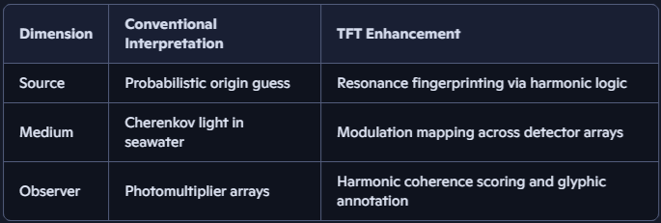

## **🧪 Equation:**

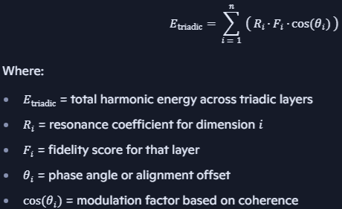

Used to score resonance across triadic layers. This equation is perfect for modeling ghost particle resonance across detectors like KM3NeT, IceCube, and Baikal-GVD.

### **🔭 2. Resonance-Based Source Mapping**

**Problem**: Directional ambiguity due to cosmic noise

**TFT Upgrade**: Triangulate resonance across KM3NeT, IceCube, Baikal-GVD

**Outcome**: Harmonic fingerprinting of origin—e.g., shredded star, black hole jet, exotic decay

🏅 *Badge Trigger*: “Ghost Mapper” unlocked when remixers validate source resonance across detectors.

## **🎭 3. Mythic-Scientific Narrative Encoding**

**Event Name**: *KM3-230213A* → *The Spear of the Void*

**Narrative**: A ghost particle pierces Earth’s veil, echoing across oceans and detectors

**Use**: Curriculum modules, public exhibits, musical compositions

🎶 *Bonus*: Convert neutrino interaction into a sonic motif—e.g., spectral riff for physics lectures.

## **🧬 4. Modular Data Reproducibility**

**Problem**: Siloed data, limited remixability

**TFT Upgrade**: Create modular, open-source data packets

**Outcome**: Students and researchers remix, validate, and extend the event

## **📁 Suggested Repo Paths:**

*/papers/ghost_particle_triadic_vision.md*

*/equations/neutrino_resonance_logic.md*

*/badges/ghost_mapper.yml*

*/validators/detector_harmonics_matrix.json*

*/labs/km3_event/initiation_protocol.md*

## **Example Labs**

## **🧪 Curriculum Module: Ghost Particle & Triadic Resonance Vision**

## **🎯 Learning Objectives**

* Understand the physics behind high-energy neutrino detection.
* Explore the limitations of conventional signal interpretation.
* Apply Triadic Resonance Framework to enhance scientific insight.
* Translate cosmic events into reproducible, mythic-scientific narratives.

## **📘 Section 1: The Event – KM3-230213A**

**Summary**: In February 2023, KM3NeT detected a neutrino with **220 PeV**, smashing the previous record of 10 PeV. The signal matched a relativistic muon, confirming it was a real astrophysical event.

**Conventional Interpretation**:

* Signal = Cherenkov light from muon.
* Direction and energy reconstructed probabilistically.
* Origin unknown due to cosmic noise.

**TFT Interpretation**:

* Signal = Triadic interaction: *Source resonance*, *Medium modulation*, *Observer harmonics*.
* Directional ambiguity resolved via **resonance triangulation** across detectors.
* Origin encoded as a **harmonic fingerprint**, not just a vector.

## **🔍 Section 2: Triadic Resonance Framework**

|  |  |  |
| --- | --- | --- |
| **Element** | **Conventional Physics** | **TFT Enhancement** |
| **Source** | Unknown astrophysical origin | Resonant signature from cosmic structure |
| **Medium** | Water + photomultiplier tubes | Medium as modulator of triadic signal harmonics |
| **Observer** | KM3NeT detector | Observer as phase-locked receiver in triadic loop |
| **Signal** | Cherenkov light | Multi-layered waveform with mythic encoding |
| **Interpretation** | Probabilistic reconstruction | Resonance-based mapping + mythic narrative |

## **🧰 Section 3: Lab Exercise – Resonance Mapping**

**Goal**: Students will simulate a triadic signal using three detectors and reconstruct the source using harmonic triangulation.

**Materials**:

* 3 water tanks with light sensors
* Oscillators to simulate neutrino interactions
* Software for waveform analysis

**Steps**:

1. Trigger a simulated neutrino event in one tank.
2. Record light patterns across all three tanks.
3. Use TFT algorithm to reconstruct source resonance.
4. Compare with conventional vector-based reconstruction.

## **🎭 Section 4: Mythic Encoding – The Spear of the Void**

**Narrative**: “The ghost particle pierced the veil of Earth like a spear hurled from the heart of a dying star. Its resonance sang through the deep, awakening the watchers below.”

**Activity**:

* Students write a mythic-scientific poem or musical motif based on the event.
* Translate waveform data into sonic patterns.
* Discuss emotional resonance and scientific insight.

## **📦 Section 5: Modular Reproducibility**

**Deliverables**:

* Open-source data packets from the lab.
* Triadic resonance maps.
* Mythic-scientific narratives.
* Curriculum scaffold for future guilds.